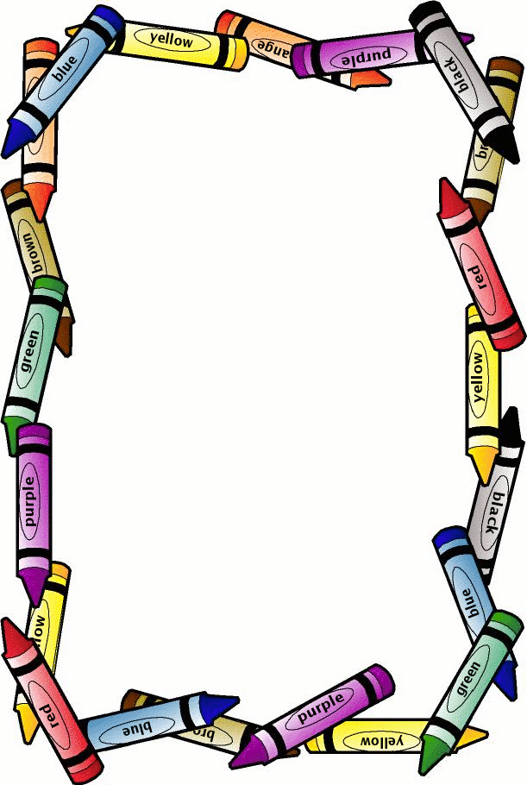

BPA 2018-2019

Kindergarten and First Grade Fieldtrip

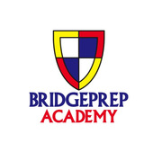

We are going on a field trip to the **Crayola Experience**! Reminder this excursion is limited to 48 students. This is a first come, first serve situation. Please make your payments ASAP.

Fieldtrip Details

Date: 1/17/2019

**Cost: $22.00**

**Payment Due By: 1/11/2019**

Arrival Time: 10 AM/ Departure Time: 2:30 PM (school arrival and dismissal time remain the same for the grade levels)

Lunch will be provided by BPA